State of Alaska
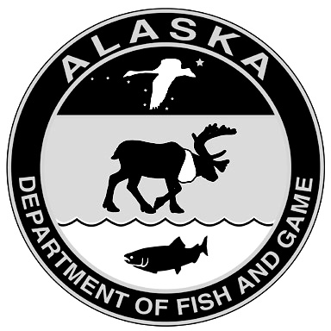
Department of Fish and Game
Scientific Permit Application

Part A: Applicant Information
Applicant Name:
Organization:
Mailing Address: |  | City: | State: | Zip:
Email Address: |  | Phone: | Cell:

Administrative contact for permit (if different than above):
Name: | Email: | Phone:

Part B: Project Summary (please attach study plan)
Project Title:
Principal Investigator (if not applicant): |  |  |  |  | Requested Start Date:
IACUC Status: | Final Approval (attach copy) |  | Pending |  | Not required
This project will involve (check all that apply):
lethal collection | live capture | captive study |  | salvage |  | survey or other ( )

Please provide the dates and locations (be specific) of your proposed field activities:

Please provide a summary of the activities for which you are requesting a permit (include species, sample sizes, marking, surgical, or other procedures, biological samples to be taken, etc.). You must complete this section; do not reference your study plan in lieu of providing a summary.

Disposition of specimens (lethal collection or captive only):

I certify that all statements entered on this application are true and that I will abide by all conditions and restrictions of a permit if awarded.
 | (Signature of Applicant)* |  | (Date)
*Signature not required if application is submitted via an official government or university email address.

Your application must include the following (additional materials may be requested following initial review):
- completed application form
- study plan
- current (final) IACUC approval.
Completed applications should be emailed to dfg.dwc.permits@alaska.gov. Mail signed originals to Alaska Department of Fish & Game/Wildlife, Permits Section, P.O. Box 115526, Juneau, AK 99811-5526.

