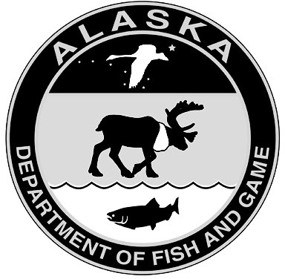
State of Alaska Department of Fish and Game
Application to Renew/Amend Public Safety Permit

Part 1: General Information
Permittee Name: |  | Permit No:
Organization:
Mailing Address:
City: | State: | Zip code:
Email: | Phone:
Administrative contact for permit (if different than above):
Name: | Email: | Phone:

Part 2: Proposed Changes

Please describe the changes you would like to make to the permit conditions and include a brief justification for the change.

Completed applications should be emailed to dfg.dwc.permits@alaska.gov

SPRA (Rev. 11/21)

