Figure 5a. Cross-sectional view Alaskan Sugar Kelp Longline (grower fill in depth G and L)
H (not to scale)

400 feet
E F

I 7 feet
-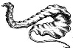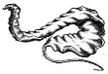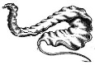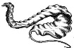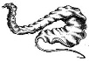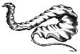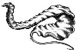 G_____feet
D
C
J
B _______feet K_____feet
A
A. Mooring (200 lb. mushroom anchor or auger or granite block or 2000 lb. cement block)
B. Grower fill in anchor line length and materials (3/1 scope typical)
C. 7/16 inch seeded kelp poly line 400 feet long and 7 feet below the surface
D. 5-10 lb. cement weights or three holed bricks to keep kelp 7 feet below surface
E. Surface mooring ball 18 inch diameter 100 lb. displacement
F. 5/16 inch poly depth 7’ control line (dropper) , 6x14 inch foam surface buoy and weight (D)
G. Water depth at low tide H. Longline section (400 feet typical, grower fill in if different)
I. 7 feet ½ inch chain to shackle. J. Line holdfast K. Distance from kelp longline to bottom
Figure 5b. Detailed Drawing - Plan view Alaskan Sugar Kelp Longline

(not to scale)

D

A B C

A Mooring
B Mooring buoy
C Kelp longline with surface buoys
D 400 foot kelp longline section (grower fill in if different)

Figure 5c. Detailed Drawing - Details on kelp depth control line dropper

A

D
B

C

A. 6 x 14 inch lobster buoy
B. 1 inch pvc pipe with a lobster spindle washer and figure 8 knot of 5/16 poly rope on each end
C. 10 lb. cement weight from ½ gallon paint bucket with knotted 5/16 poly loop or 3-holed brick
D. 7 foot length

Figure 5d. Detailed Drawing - Anchoring system with configuration and poundage (fill in and /or add anchor drawing).

300 ft length
Buoy details: ______________
Anchor line details: _________________
Chain or cable details: __________________

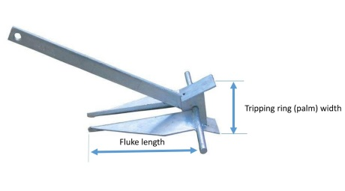
Anchor details: ____________

Mooring detail to be filled out by grower in Figure 5.

