STATE OF ALASKA
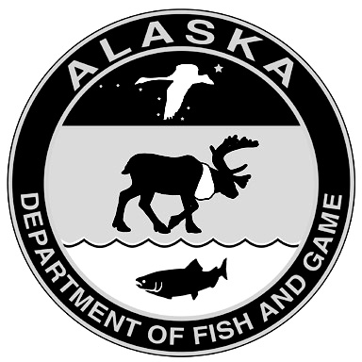
DEPARTMENT OF FISH AND GAME
Application to Renew or Amend Scientific Permit
(Multi-Project Application)

Part 1: General Information
Permittee Name: |  |  | Permit No:
Organization:
Mailing Address:
City: |  | State: | Zip code:
Email: |  | Phone:

Administrative contact for permit (if different than above):
Name: | Email: | Phone:

I certify that all statements entered on this application are true and that I will abide by all conditions and restrictions of a permit if awarded.
(Date)

Part 2: Project Information
For each project, please provide all information requested below (text boxes will expand as needed).
- Minor changes include small changes to sample sizes, species, locations, etc. Describe the proposed changes in the box provided and include a brief justification.
- Major changes include substantially expanding the scope of an existing project. For major changes and new projects, please provide a brief summary of all activities for which you are requesting a permit, including dates and locations of field work, species, sample sizes, marking, surgical, or other procedures, biological samples to be taken, and final disposition of specimens. You must also attach a study plan.
IACUC Status: All renewals,amendments, and new projects require submission of a current IACUC approval that includes the proposed changes. For more information, see the Policy and Requirements for Scientific Permits or call the Permits Section at (907) 465-4148.
Study Plan: Please check the box if study plan is attached (required for major changes and new projects only).
Completed applications should be emailed to dfg.dwc.permits@alaska.gov or mailed to Alaska Dept. of Fish & Game/Wildlife, Permits Section, P.O. Box 115526, Juneau, AK 99811-5526.
Project Title: |  | Renew Amend New
Principal Investigator (if not permittee): |  | Start Date:
Changes: (describe below) | IACUC: Approval Pending | Study Plan

Project Title: |  | Renew Amend New
Principal Investigator (if not permittee): |  | Start Date:
Changes: (describe below) | IACUC: Approval Pending | Study Plan

Project Title: |  | Renew Amend New
Principal Investigator (if not permittee): |  | Start Date:
Changes: (describe below) | IACUC: Approval Pending | Study Plan

Project Title: |  | Renew Amend New
Principal Investigator (if not permittee): |  | Start Date:
Changes: (describe below) | IACUC: Approval Pending | Study Plan

Project Title: |  | Renew Amend New
Principal Investigator (if not permittee): |  | Start Date:
Changes: (describe below) | IACUC: Approval Pending | Study Plan

Project Title: |  | Renew Amend New
Principal Investigator (if not permittee): |  | Start Date:
Changes: (describe below) | IACUC: Approval Pending | Study Plan

