State of Alaska
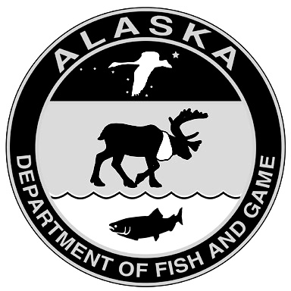
Department of Fish and Game
Application to Renew or Amend Scientific Permit

Part 1: General Information
Permittee Name: |  |  | Permit No:
Organization:
Mailing Address:
City: |  | State: | Zip code:
Email: |  | Phone:

Administrative contact for permit (if different than above):
Name: | Email: | Phone:

Project Title:
Principal Investigator (if not permittee): |  |  | Requested Start Date:
Action Requested:* |  |  | IACUC Status:**
Renewal | Amendment |  | IACUC approval attached
no changes | minor |  | IACUC approval pending
minor changes | major |  | Study plan attached (required for major changes only)
major changes | add new project |  | Study plan attached (required for major changes only)
*Minor changes include small changes to sample sizes, species, locations, etc. Major changes include substantially expanding the scope of an existing project or adding a new project to an existing permit. Major changes require submission of a study plan.
**All renewals and amendments require submission of a current IACUC approval that includes the proposed changes. For more information, see the “Policy and Requirements for Scientific Permits” or call (907) 465-4148.
I certify that all statements entered on this application are true and that I will abide by all conditions and restrictions of a permit if awarded.
(Date)

Part 2: Proposed Changes
Please describe the changes you would like to make to the permit conditions and include a brief justification for the change.
For major changes (including new projects), attach a study plan and provide a brief summary of the activities for which you are requesting a permit, including dates and locations of field work, species, sample sizes, marking, surgical, or other procedures, biological samples to be taken, and final disposition of animals:
Completed applications should be emailed to dfg.dwc.permits@alaska.gov or mailed to Alaska Dept. of Fish & Game/Wildlife, Permits Section, P.O. Box 115526, Juneau, AK 99811-5526.

